**TOOLS NEEDED:**

* Banding Cutters
* Pipe Wrench
* Rubber Mallet
* Impacts or a ratchet (3/4” socket & 9/16” socket)
* A combination of open ended 3/4” & 9/16” wrenches or a crescent wrench­­
* 4FT Level
* A Friend

**Unpacking and Pre-Assembly**

1. **Unpacking:**
   * Tools needed: Banding Cutters (or any kind of knife to cut plastic).
   * Familiarize yourself with the blueprint (design) of your dock. There is a key in the upper left-hand corner or your drawing to show you what the different symbols mean.
   * Remove modules from the pallet and lay them out in numeric order if possible. The module number can be found on the side or end of each module. All your brackets & modules are labeled, so you can match up which bracket or module goes in what configuration.
   * All brackets, hardware, and accessories are packed inside the modules starting with modules closest to the bottom.

1. **Leg Assembly:**
   * Tools needed: 9/16” socket.
   * Locate all legs and footpads before starting assembly.
   * Set footpad on a firm, flat surface and slip galvanized leg into the collar – The bottom of the leg should be inserted all the way into the footpad.
   * Tighten the set screw to secure (to ensure leg doesn’t move). Complete all leg/footpad assemblies.
   * Refer to the drawing for “suggested leg length”. Place completed leg assemblies, of the specified length, next to each module. Typically, the first module will have four (4) legs and the rest will have two (2).

1. **Bracket Assembly:**
   * Tools needed: 3/4” socket
   * Refer to the drawing for correct bracket designations – “A”, “B”, “C”, “D” or “E”. Select the appropriate bracket and place it near the leg assembly at each module.
   * Again, the brackets have been labeled for your convenience.
   * Using a ¾” socket, adjust the set screw on the bracket sleeve to allow the leg to slide through. Slide the bracket onto the leg assembly.
   * Refer to the drawing for “estimated water depth” and adjust the leg so that the distance between the top of the footpad and the bottom of the bracket sleeve is approximately equal to the correlated water depth.
   * Snug the set screw with a wrench – DO NOT OVERTIGHTEN. Finger tight plus a ¼ to ½ turn with the wrench should be sufficient. These will be fully tightened in the final adjustment process.

1. **Bracket Installation:**
   * Tools needed ¾” Socket & ¾” Wrench & Rubber Mallet
   * Lift the end of the module and slip the bracket assemblies into position (you may need to use a rubber mallet to fit the bracket into place). Insert a bolt assembly into the holes of each bracket and install the lock nut finger tight. DO NOT OVER TIGHTEN.
   * If job site space is available, install the bracket assemblies on all the modules. If not, complete as many as space allows and start module installation (**NOTE**: it may be harder to move modules with the legs attached and depending on depth of water, it may be easier to attach the legs and brackets in the water). Stage modules, bracket assemblies, and bolt kits for later completion.

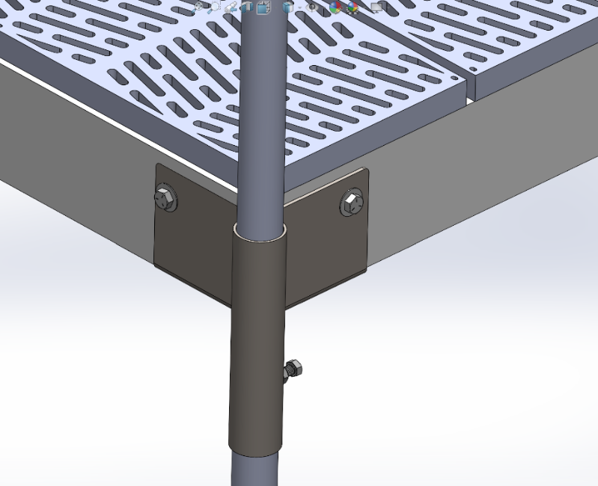

1. **Accessory Installation:**
   * Tools needed: 1/2” and/or 9/16” socket.
   * Refer to the drawing for the location of accessory items (bench, ladder, mooring cleats, module hinge kits, etc.).
   * Install accessory item(s) on modules after installing the bracket assembly and before putting the module in the water.

**Dock Installation**

1. **Shoreline Transition:**
   * No tools needed.
   * If a hinged transition ramp or module with hinge kit is included in the dock package, this will be the second module installed. Stage on the shoreline accordingly.
2. **First Module Installation:**
   * No tools needed.
   * The first module to be installed will be the module with four bracket assemblies (one on each corner) and will be labeled #1.
   * Carry the module to the water and position it as desired. If a transition ramp or module with hinge kit is being used, be sure to position the module accordingly.
   * The module should be reasonably level. A typical installation will have the bottom of the bracket sleeve approximately ½” above the water. This dimension will obviously be modified to accommodate unusually high or low water conditions (using the bottom of the bracket sleeve and the surface of the water as an index eliminates the need for a carpenter's level to adjust the dock).
   * If the module is severely out of level or alignment, use the bracket sleeve set screws to adjust. This can be accomplished as follows:
     + With a ¾” wrench in one hand, place one foot on the footpad and use your other hand to support the module.
     + Loosen the set screw and raise or lower the bracket assembly so that the bottom of the bracket sleeve is above the surface of the water approximately ½”. Then retighten the set screw.
3. **Shoreline Transition Installation: (Skip this step if your dock does not include a transition)**
   * No tools needed.
   * If a transition ramp or module with a hinge kit is used, set the ramp or module in position and align the module hinge barrels to allow for the installation of the stainless-steel hinge pin. Adjust module positions as required and double-check to make sure the first module is still reasonably level.
4. **Second and Subsequent Module Installation:**
   * No tools needed.
   * The second module to be installed will be labeled #2 and have 2 bracket assemblies installed on the end with the label. Carry the module into the water legs first and position it in front of the first module so that the end without brackets can be inserted into the brackets of the previous section.
   * Adjust the legs if necessary and install bracket bolts with PVC washers. Install flange nuts and tighten just finger tight. Adjust height if needed.
   * Look for the module with the next number and install it in a similar fashion. Continue this process until the dock is completely installed.

**Final Adjustments**

1. **Re-Level & Tighten Bracket Bolts:**
   * Tools needed: 3/4” socket.
   * Depending upon bottom conditions (muddy, rocky, sandy etc.) the dock could settle unevenly during installation. We recommend that after the initial installation is complete, you walk on the dock to ensure it settles completely.
   * Check to make sure the legs are vertical -start with the legs closest to shore and work towards the outside end. Make sure all the legs are between 5” and 15” above the top of the dock. If the legs are too short, they should be replaced with a longer leg. If they are too long, they can be trimmed with a hacksaw, sawzall, or pipe cutter
   * If the module is severely out of level or alignment, use the bracket sleeve set screws to adjust. This can be accomplished as follows:
     1. With a ¾” wrench in one hand, place one foot on the footpad and use your other hand to support the module.
     2. Loosen the set screw and raise or lower the bracket assembly so that the bottom of the bracket sleeve is above the surface of the water approximately ½”. Then retighten the set screw.
   * After leveling the module, you may now tighten the bracket bolts- Be careful not to over-tighten the bolts as it may damage the module.
2. **Install Post Covers:**
   * No tools needed.
   * The post covers have the same letter designation as the brackets (“C” and “D” brackets use the same cover and the “E” bracket does not have a cover).
   * Firmly push the cover down until the bracket set screw pops through the access hole in the cover.
   * Once the cover is on, it is very difficult to remove. We find it easiest to completely remove the bracket set screw and then remove the cover.
3. **Completion:**
   * Congratulations, you're done! Now you can stand back and appreciate your efforts and enjoy your dock for many years to come.

**Footnotes**

* **Leg Assembly:** When installing the dock in an area where currents exist such as rivers, tidal areas, etc., use small auger feet instead of footpads.
* **Accessory Installation:** When installing a module hinge, the hinge plate goes on the outside of the bracket – typically an “A” bracket.